**AI - POWERED NUTRITION ANALYZER FOR FITNESS ENTHUSIASTS**

A PROJECT REPORT

Submitted by

TEAM ID PNT2022TMID33008

PRIYADHARSHINI.D 820419106041

PRIYADHARSHINI.N 820419106042

PRIYANKA.G 820419106043

DEEPA.S 820419106009

in partial fulfilment for the award of the degree of

BACHELOR OF ENGINEERING

IN

ELECTRONICS AND COMMUNICATION ENGINEERING

ANJALAI AMMAL MAHALINGAM ENGINEERING COLLEGE ,

KOVILVENNI , THIRUVARUR -614403.

(Approved by AICTE,New Delhi & Affiliated to Anna University,Chennai)

**INTRODUCTION:**

**Abstract:**

A healthy diet has been a concern for many health conventions. Today, nutrition analysis tools make it easier to maintain a healthy eating pattern. Nutrition Analysis is the process of analysing foods to determine their nutritional content. The main objective of the project is to build a model used to classify fruit images based on different characteristics and image.A nutrition analyser is used to estimate and predict calories based on deep learning techniques. Its purpose is to maintain a healthy lifestyle by tracking diet and exercise habits.

**Project Overview:**

* To know the fundamental concepts and techniques of Convolutional Neural Network and Broad understanding of image data.
* To pre-process/clean the data using different data pre-processing techniques.
* Build a web application using the Flask framework. The user interacts with the UI (User Interface) and gives the image as input, then the input image is then passed to our flask application, and finally with the help of the model which we build we will classify the result and showcase it on the UI.

**Purpose:**

AI Algorithms may help better understand and predict the complex and non-linear interaction between nutrition - related data and health outcomes.

These nutrition analyser tools enable more opportunities to help people understand their daily eating habits, exploring nutrition patterns and maintain a healthy diet.

**LITERATURE SURVEY:**

**Existing Problem**:

People who don’t aware about the nutrient content in they are consuming that lead to lack of appetite, or decrease hunger, is one of the most troublesome nutrition problems they are experiencing which leads to nutrition disease, nutrition related diseases and conditions that cause illness in humans. They include deficiencies or excesses in the diet, obesity and eating disorder, and chronic diseases such as diabetes mellitus.

Artificial Intelligence in Nutrients Science Research: A Review

Author :[Jarosław Sak](https://pubmed.ncbi.nlm.nih.gov/?term=Sak%20J%5BAuthor%5D) and [Magdalena Suchodolska](https://pubmed.ncbi.nlm.nih.gov/?term=Suchodolska%20M%5BAuthor%5D)

Artificial intelligence (AI) as a branch of computer science, the purpose of which is to imitate thought processes, learning abilities and knowledge management, finds more and more applications in experimental and clinical medicine. In recent decades, there has been an expansion of AI applications in biomedical sciences. The possibilities of artificial intelligence in medical diagnostics, risk prediction and support of therapeutic techniques are proliferating. The aim of the article is to analyse the current use of AI in nutrients science research. The literature review was conducted in PubMed. A total of 399 records published between 1987 and 2020 were obtained, of which, after analysing the titles and abstracts, 261 were rejected. In the next stages, the remaining records were analysed using the full-text versions and, finally, 55 papers were selected. These papers were divided into three areas: AI in biomedical nutrients research (20 studies), AI in clinical nutrients research (22 studies) and AI in nutritional epidemiology (13 studies). It was found that the artificial neural network (ANN) methodology was dominant in the group of research on food composition study and production of nutrients. However, machine learning (ML) algorithms were widely used in studies on the influence of nutrients on the functioning of the human body in health and disease and in studies on the gut microbiota. Deep learning (DL) algorithms prevailed in a group of research works on clinical nutrients intake. The development of dietary systems using AI technology may lead to the creation of a global network that will be able to both actively support and monitor the personalized supply of nutrients.

AI for Understanding Food and Nutrition

Author**:** Barbara Korousic Seljak, Tome Eftimov, Fabio Mainardi

Topics of interest include algorithms, methods, and systems related to food and nutrition:

- Information retrieval and extraction in efforts to build food ingredient databases;

- Data normalization, ontologies, and ontology design in efforts to record individual eating patterns with great detail and link eating to important locational, temporal, and social factors, including unstructured (social media, text, images etc.) and structured data resources;

- Predict relationships between food and nutrition and health behaviours, linking this to health and environmental outcomes;

- Recommender systems in efforts to build personalized nutrition systems and drive food choices;

- NLP frameworks in efforts to inform community interventions and population health and environment policies that affect access to and consumption of food;

- Digital tracking tools, wearable devices, and other sensors in efforts to record, represent, and analyse quantified-self data, and link food consumption to health and environmental sustainability.

How Nutrition AI Determines People's Health Metrics?

Author: ThinkMl team

Randomized trials in the nutrition field are complex because this technique demands sticking to a diet for years, resulting in higher human error chances. There are several factors of dietary recommendations that influence everyone differently; hence, the ideology of a universal diet plan for everyone fails here as it is impossible biologically. Artificial intelligence allows researchers to analyse big data and better understand how diet affects human health patterns, including factors influencing their nutritional needs.

AI Diet Planner: Use of AI to determine your diet plan

The food business uses AI in a variety of ways, such as anticipating the influence of a taste or utilizing robots in manufacturing. A diet plan driven by AI is rapidly gaining traction, with the ability to create tailored diet programs based on our physical characteristics and exact objectives.

Personalized Nutritional Guide by Artificial Intelligence

Micronutrients strives to integrate genomic science with nutrition to improve nutritional-based artificial intelligence. DNA tests recommend a personalized diet plan focusing on specific aspects of a person's microbiome, including lifestyle, genetics, and surroundings. These suggestions are based on data extracted from billions of human dietary patterns. Such nutritional guides based on the micronutrient approach help scientists leverage AI for personalized recommendations and interventions.

Artificial intelligence made it possible to analyse personal health metrics and give birth to many ongoing projects in the same field. For instance, smartphone nutritional applications are developed that use deep learning to analyse photos of plates for streamlining food logging processing without human-based errors. However, a complete dataset must comprise major factors like sleep patterns, activity levels, microbiome functioning, and medication consumption. Advanced algorithms help achieve this goal by tracking important health metrics for personalized AI diet chart plan development. In the coming five to ten years, it is expected that AI and ML techniques will grow further in the nutrition and fitness department.

A Survey on Automated Food Monitoring and Dietary Management Systems

Author: Vieira Bruno, Silva Resende, Cui Juan

Healthy diet with balanced nutrition is key to the prevention of life-threatening diseases such as obesity, cardiovascular disease, and cancer. Recent advances in smartphone and wearable sensor technologies have led to a proliferation of food monitoring applications based on automated food image processing and eating episode detection, with the goal to conquer drawbacks of the traditional manual food journaling that is time-consuming, inaccurate, under-reporting, and low adherent. In order to provide users feedback with nutritional information accompanied by insightful dietary advice, various techniques in light of the key computational learning principles have been explored. This survey presents a variety of methodologies and resources on this topic, along with unsolved problems, and closes with a perspective and border implications of this field.

Mobile-Based Diet Monitoring System for Obesity Management.

Author: Bruno Vieira Resende E Silva, M. Rad, J. Cui, Megan McCabe, Kaiyue Pan

A new interactive mobile system that enables automated food recognition and assessment based on user food images and provides dietary intervention while tracking users' dietary and physical activities and the realization of real time energy balance monitoring through metabolic network simulation is presented.

Personal diet management is key to fighting the obesity epidemic. Recent advances in smartphones and wearable sensor technologies have empowered automated food monitoring through food image processing and eating episode detection, with the goal to conquer drawbacks of traditional food journaling that is labour-intensive, inaccurate, and low adherent. In this paper, we present a new interactive mobile system that enables automated food recognition and assessment based on user food images and provides dietary intervention while tracking users' dietary and physical activities. Also using techniques in computer vision and machine learning, one unique feature of this system is the realization of real time energy balance monitoring through metabolic network simulation. As a proof of concept, we have demonstrated the use of this system through an Android application.

Integrating Concepts about Food, Nutrition and Physical Activity

Authors: Jennifer Adkins Ernst , MS Anastasia Snelling, PhD, RD Devin Ellsworth

The Community Voices for Health curriculum “Integrating Concepts about Food, Nutrition and Physical Activity into Middle School” is intended to help you increase the amount of nutrition education and physical activity you are providing for your students. Educators agree that healthier students are better learners (Basch, C.), so empowering students to make healthy food choices and be physically active is very important to academic achievement. Healthy environments, good role-models, and learning opportunities all contribute to improving the health behaviours and academic outcomes of your students. The following conceptual model will stimulate teachers’ interest in topics about food, food production, gardening and nutrition, and help them seamlessly include them in their regular lesson plans. The curriculum is organised into six nutrient content areas - carbohydrates, protein, fat, vitamins, minerals and water. Each content area contains fundamental food, growing, nutrient and food labelling information, common core standards for maths, language arts, science and history, provocative facts and questions, and lesson suggestions. The intent of the design is that teachers can easily coordinate with their colleagues across their grade, and the school, to focus the delivery to suit your school schedule and priorities

**Problem Statement Definition:**

A Problem Statement is a description of an issue to be addressed or condition to be improved upon. Statement of a Current issue or problem of the users based on the nutritional Problem or deficiency and individual experience about the shortage of essential nutrients or some specific Nutrient.

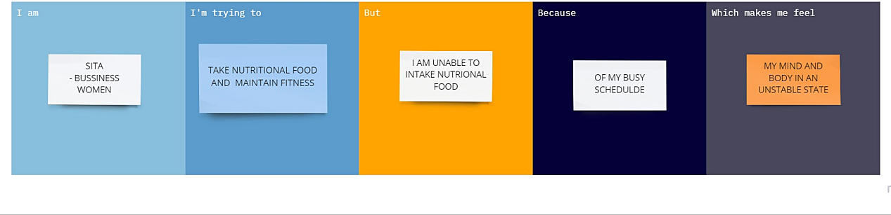

**IDEATION AND PROPOSED SOLUTION**:

**Empathy map canvas**:

An Empathy map which helps identify and describe the users needs pain points and it gives valuable information for improving the user experience. It helps to understand the various reasons for experience.

* What do users say and do?
* What do users think and do?
* What do users see and hear?

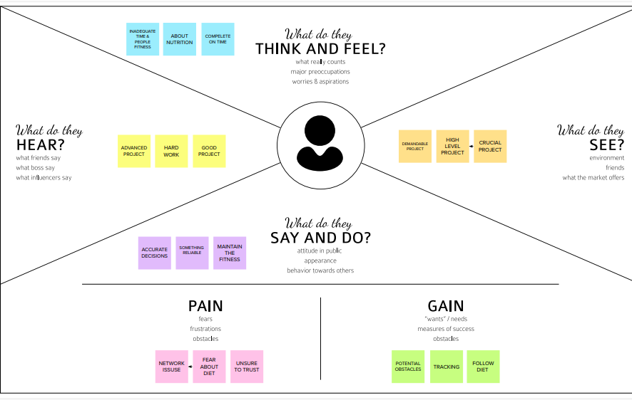

**IDEATION AND BRAIN STORMING**:

Ideation describe the entire process of developing the formalizing ideas.Brainstorming is primary role in the process. Ideation and the Brainstorming as the formative stage of the group discussion where everyone expose their ideas regarding the issues. One or more people directing their thoughts towards the particular that problem and issue. Typical brainstorming tools take the form of the graph that helps the prioritize and specific ideas into the scope of the project

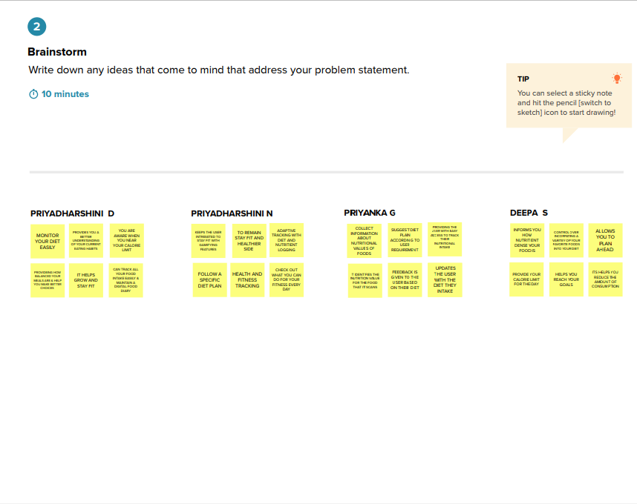

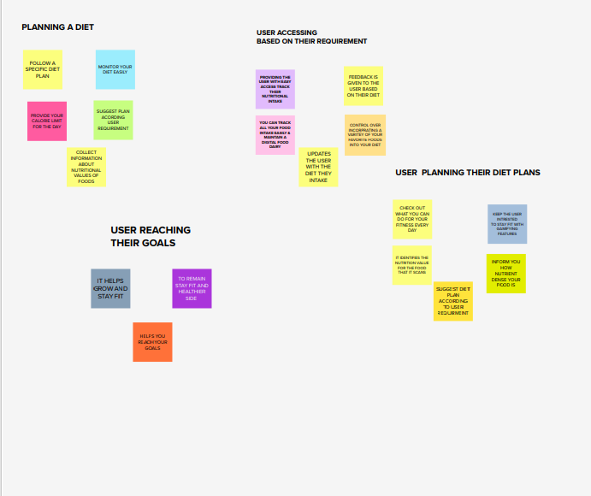

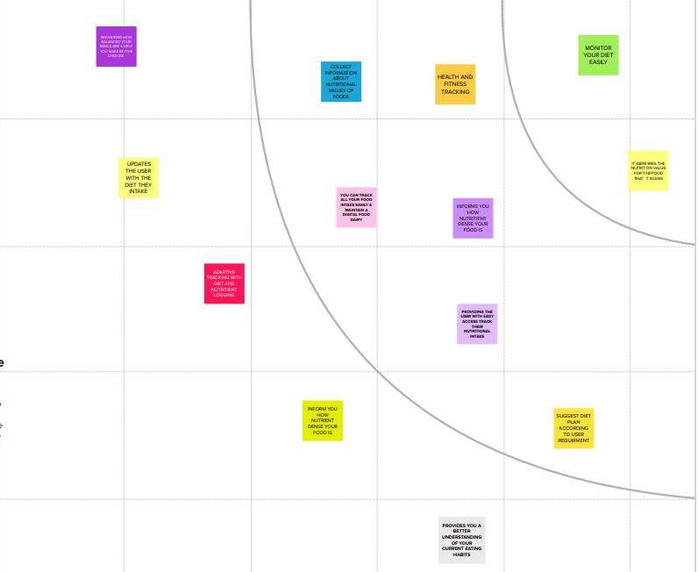

**Proposed Solution :**

Main goal of presenting a proposed solution to provide solution for given problem which faced by a potential buyer .It should be as comprehensive and address all the needs that pointed.

|  |  |  |
| --- | --- | --- |
| **S. No** | **Parameter** | **Description** |
|  | Problem Statement (Problem to be solved) | Sita is a business woman who needs a way to intake Nutritional food because of her busy scheduled need to track her Nutritional intake so that she can maintain her health. |
|  | Idea / Solution description | AI Nutrition Analyser can automatically recognize food items and compute the recommended volume and nutritional information of that food items. |
|  | Novelty / Uniqueness | Customization,  User friendly nutritional calculator,  Intuitive |
|  | Social Impact / Customer Satisfaction | Easy and quick handy nutrition calculators for all food items,  Cost effective,  To better understand their expectations & Perspectives. |
|  | Business Model (Revenue Model) | AI is one of today’s most hyped technologies with widespread advances in data capturing & manipulation, Machine learning becoming low cost & main stream .AI technologies to market still need to select the right revenue models to drive profits.  Term of Recurring revenue prospects using this guidelines subscription, service, usage based. |
|  | Scalability of the Solution | AI algorithms may help better understand and predict complex & non-linear interaction between nutrition -related data & health outcomes. It performs nutrient analysis of dietary intakes. |

**Problem Solution fit:**

Problem solution fit which found a problem with customer and that the solution we have realized for it actually solves the customer’s problem.This stages proved the existence of a problem and have designed a value proposition that addresses customer’s pains and gains.

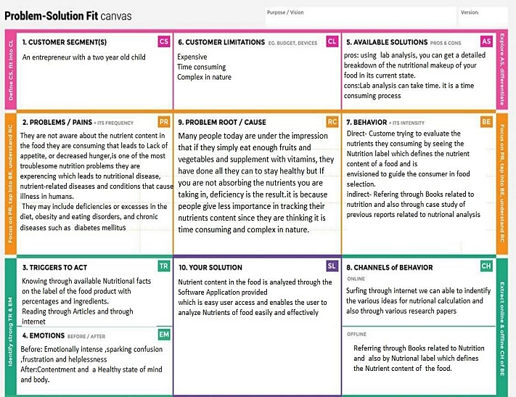

**REQUIREMENT ANALYSIS**

**Functional Requirement:**

Functional Requirements are product features or functions that developers must implement to enable users to accomplish their tasks.

It explains how the system must work and its performance. They define the basic system behaviour under the specific condition.

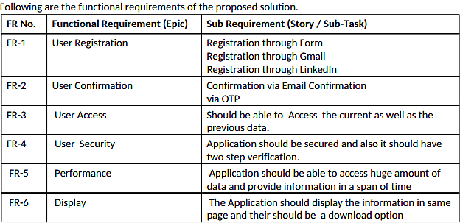

**Non -Functional Requirement:**

It defines the System Attributes such as Security, Reliability, performance, Maintainable, Scalability, Usability.

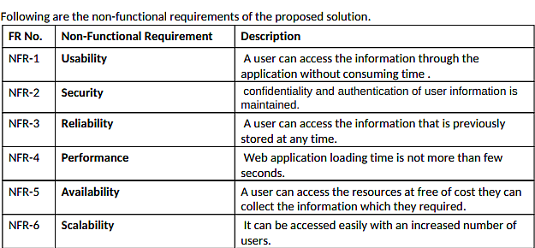

**PROJECT DESIGN**

**Data flow Diagram:** Data flow diagram is a way of representing a flow of data through the process or a system. It also provides information about the output and input of each entity and the process itself. It has no control flow and No decision rules and no loops.

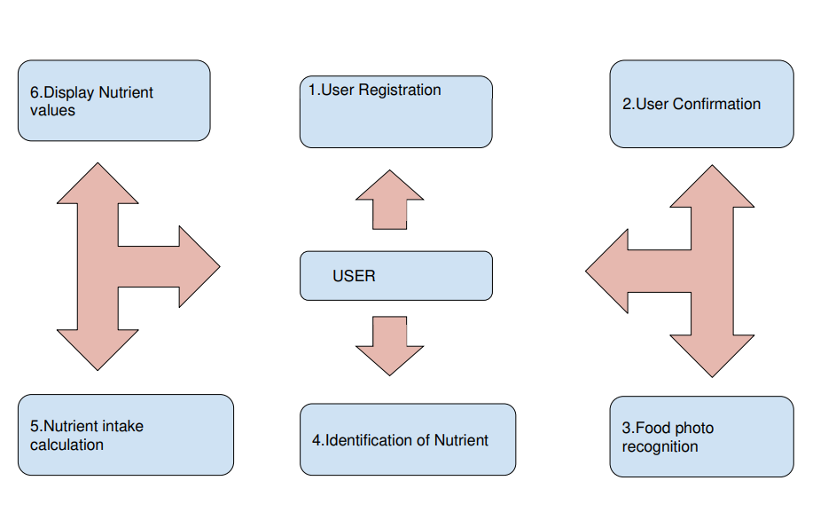

**Solution And Technical Architecture:**

Technical architecture usually goes a lot deeper into the architecture of the solution and understands the implementation from the technical level.

Solution Architecture description of a specific solution. We can understand how all the parts of the model work together, including processes and application.

**Solution Architecture:**

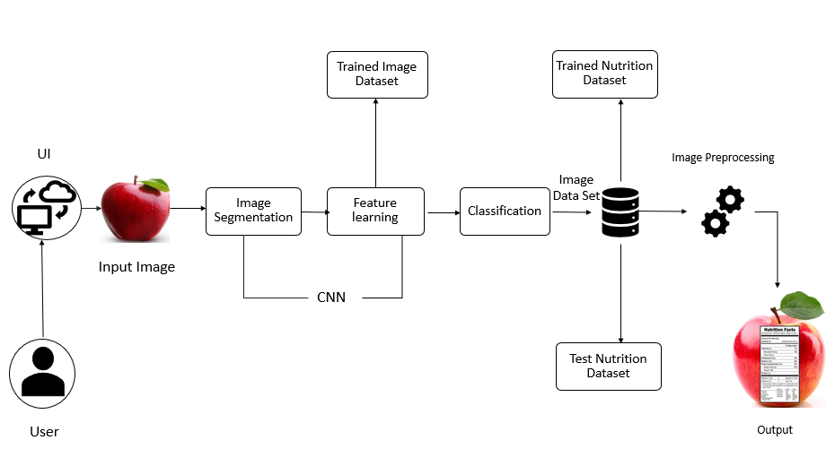

**Technical Architecture:**

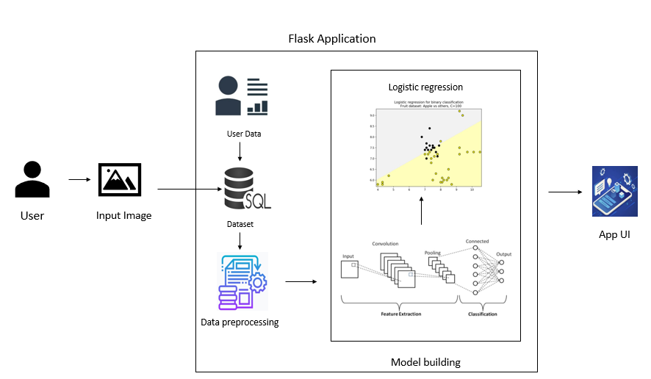

**User Stories:**

A user story is an informal, general explanation of a software feature written from the perspective of the end user or customer. Its purpose how a piece of work will deliver a particular value back to the customer.

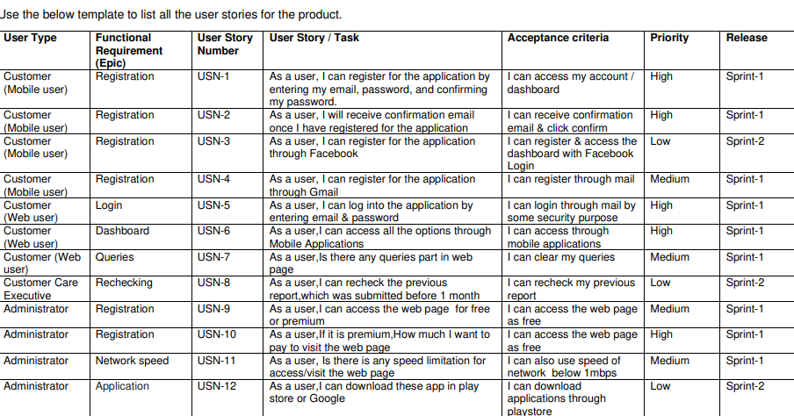

**PROJECT PLANNING & SCHEDULING**

**Sprint Planning & Estimation:**

Sprint Planning is a time boxed working session that lasts roughly one hour for every week of a sprint. The entire team agrees to complete a set of product backlog items.

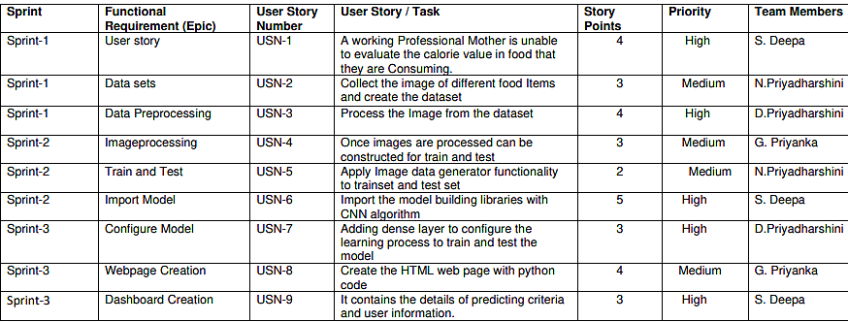

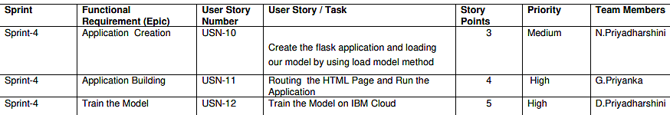

**Sprint Delivery Schedule:**

A sprint Delivery is a Document that outlines the sprint planning from end to end based on the Duration of the sprint planning [Sprint start Date to end date], Average velocity or capacity & length of the sprint.

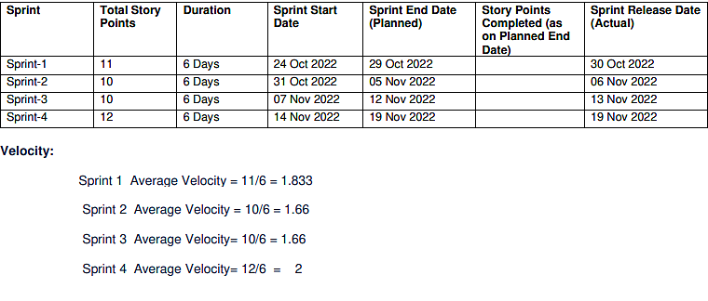

**Report from JIRA:**

Reporting helps you track and analyse team works through the project. JIRA software has ranged the report that can use of the show information about Planned and actual.

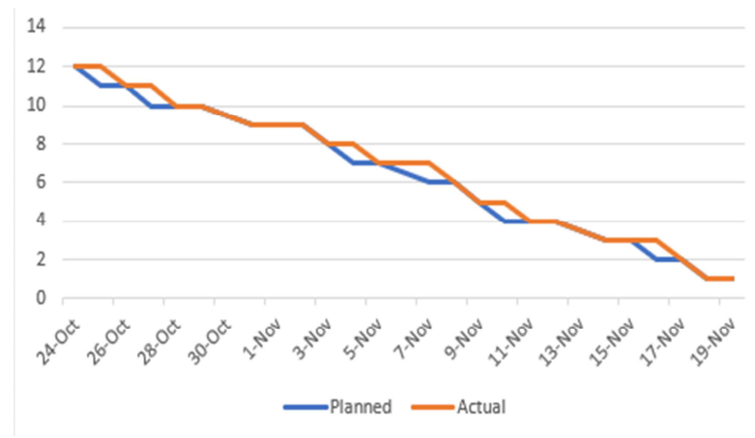

**CODING AND SOLUTIONING**

**Feature 1:**

Coding is the process of transforming ideas, solutions and instruction into the language that the computer can understand.

Using different languages ,framework ,libraries . Everything seems to be interconnected and intertwined.

We are using Deep learning neural networks library, python, flask,CNN,IBM cloud.

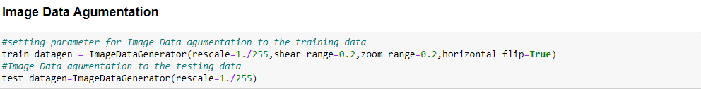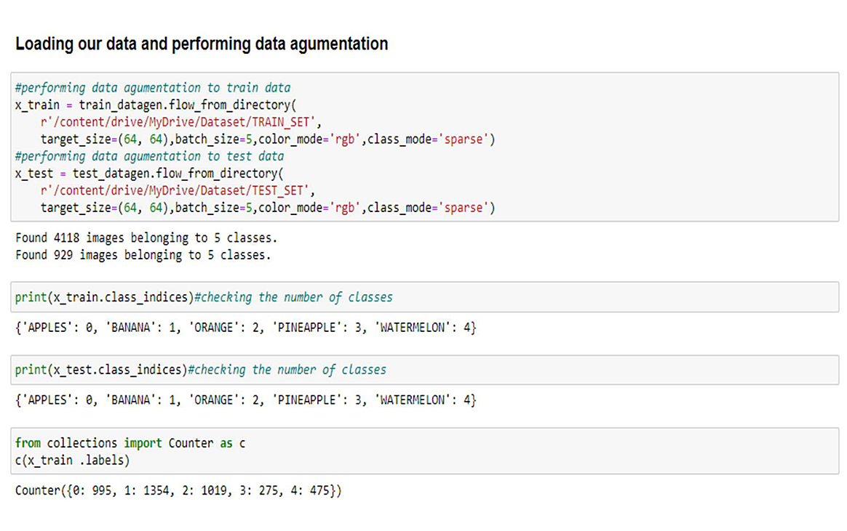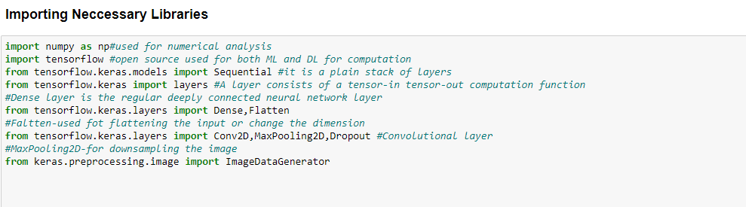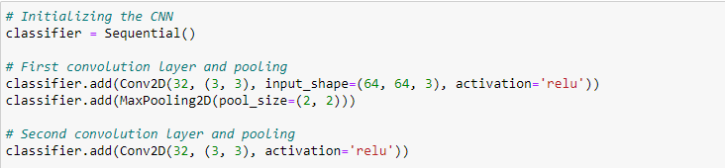

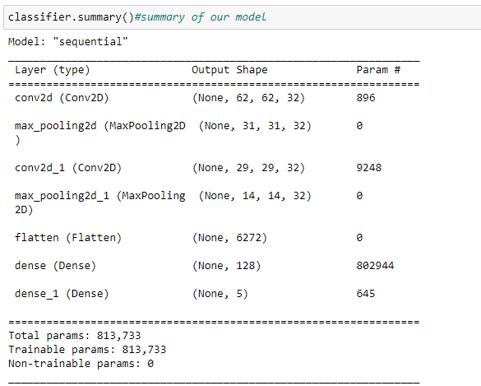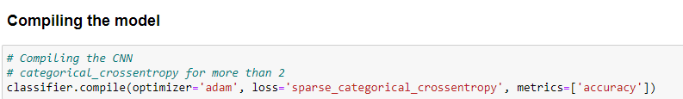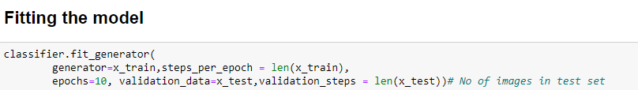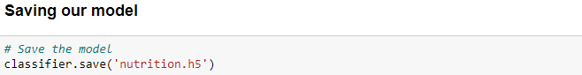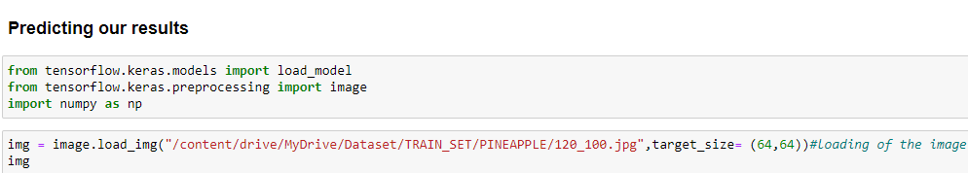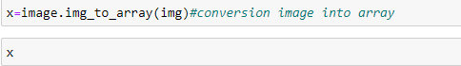









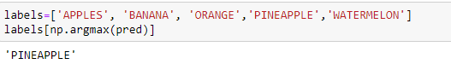

**Feature 2:**

**http://localhost:8888/notebooks/Downloads/Image%20Preprocessing.ipynb**

**http://localhost:8888/notebooks/Downloads/CNN_Image_Preprocessing.ipynb**

**http://localhost:8888/notebooks/Downloads/nutrition%20cloud(image_preprocessing).ipynb**

**http://localhost:8888/edit/Downloads/nutrition-classification.tar.gz**

**http://localhost:8888/edit/Downloads/nutrition%20(1).h5**

**TESTING**

**Test cases:**

A test case is a set of actions performed on a system to determine if it satisfies software requirements and functions correctly.

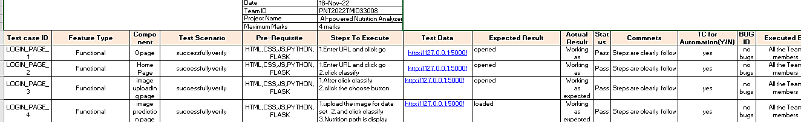

**User Acceptance Testing:**

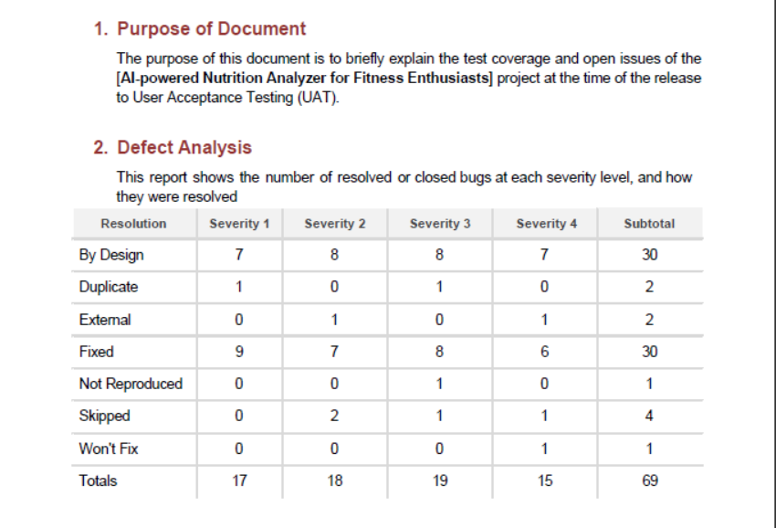

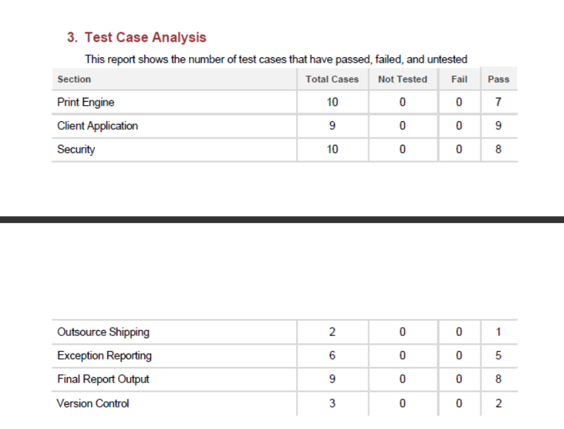

**RESULT**

**Performance Metrics:**

Performance metrics is a process of collecting, analysing or reporting the performance.Its data is used to track processes using parameters such as model summary, Accuracy and their values.

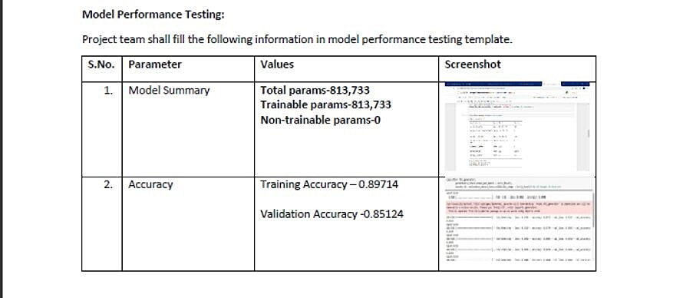

**ADVANTAGES:**

* AI Nutrition Analyser used to guide the users towards a healthy diet and assist them to achieve their health goals.
* Good to estimate calorie intake.
* It ensures that the food has optimal requirement of vitamins and minerals.
* Give more accurate values.
* Cost efficiency.

**DISADVANTAGES:**

* Applicability to other nutrients like proteins, vitamins is limited.
* Inaccurate information.
* Time consuming.

**CONCLUSION**

For fitness enthusiasts, we create a practical deep learning algorithm based on the AI-powered Nutrition Analyser. In this technique, a deep learning algorithm–based food image recognition system employs the services. We are improving the performance of the algorithm (in terms of detection accuracy). In the future, we will integrate our system into a real-world mobile device to enhance the cloud computing system. This system takes the image of the food from the user and classifies the image to measure the attributes of the food using the estimation model. The results are enhanced via image preprocessing, model building, and flask application in the IBM cloud. This classification method extracts accurate values. In the future, we will improve the usability and accuracy of the system.

**FUTURE SCOPE**

The future scope of an AI-powered nutrition analyser for fitness enthusiasts' goals is to handle health problems and issues and to help everyday people achieve their goals easily. To get more data, add more layers and increase the epochs. It can provide us with advanced abilities such as custom searches, improved visualization, etc.

**APPENDIX**

**http://localhost:8888/notebooks/Downloads/Image%20Preprocessing.ipynb**

**http://localhost:8888/notebooks/Downloads/CNN_Image_Preprocessing.ipynb**

**http://localhost:8888/notebooks/Downloads/nutrition%20cloud(image_preprocessing).ipynb**

**http://localhost:8888/edit/Downloads/nutrition-classification.tar.gz**

**http://localhost:8888/edit/Downloads/nutrition%20(1).h5**

**https://github.com/IBM-EPBL/IBM-Project-40962-1660637833.git**